Development of a Simple Business Website for Young Entrepreneurs Using Bootstrap

Gema Vizayaksa¹, Alika Raisya², Muhammad Habbly Nashrullah³, Muhammad Arifin Ilham⁴, Villian Shah Akwa⁵, Hendra⁶, Yana Adharani⁷, Nurvelly Rosanti⁸,
^{1,2,3,4,5} Universitas Muhammadiyah Jakarta
23040700041@student.umj.ac.id
ARTICLE INFO |  | ABSTRACT
Article history  Received : 21-1-2026  Revised : 13-3-2026  Accepted : 18-3-2026 |  | The utilization of digital technology has become essential in business development. However, many young entrepreneurs, students, and members of the general public still face difficulties in developing professional business websites due to limited technical knowledge and lack of structured guidance. This community service program aimed to enhance participants’ digital literacy and practical skills in developing responsive business websites using the Bootstrap framework. The program applied an educative and participatory method through online webinars and hands-on workshops. Webinar sessions delivered conceptual materials on business websites, web development fundamentals, responsive design, and Bootstrap introduction, while workshop sessions provided direct guidance for building website structures and implementing Bootstrap components. Program effectiveness was measured using pretest, posttest, and participant feedback. The pretest results showed an average score of 79.5 with varied initial understanding. After the program, the posttest average increased to 92.32, with most participants achieving high scores. Participant feedback also indicated high satisfaction with material relevance, instructor competence, and online service quality. These results demonstrate that the combination of webinars and workshops effectively improves participants’ knowledge, digital literacy, and ability to independently develop Bootstrap-based business websites.  This is an open access article under the CC–BY-SA license.
Keywords
Bootstrap; Business; Community Service; Website; Web_Developer

INTRODUCTION
The utilization of digital technology has become an essential requirement across various sectors, including business, education, and community capacity development. Business websites serve as strategic platforms for disseminating information, promoting products and services, and facilitating interactions between entrepreneurs and customers. In the context of community service activities, technology-based educational initiatives such as webinars and training programs have been proven effective in enhancing digital literacy and supporting community readiness in adapting to digital transformation (Buchori, Rahmadhani, Rozzaqi, & Khoiri, 2025)
The role of digital platforms, particularly business websites, is increasingly important for micro, small, and medium enterprises in strengthening marketing strategies and expanding market reach, especially during periods of accelerated digital adoption following the new normal era (Veranita et al., 2021). Despite the rapid development of digital technology, many individuals particularly young entrepreneurs, students, and members of the general public still encounter difficulties in developing and managing business websites. These challenges include limited technical knowledge, a lack of practical experience, and low confidence in independently managing website development processes (Ika Safitri Windiarti, Miftahurrizqi, & Haryanto, 2022).
Previous studies have demonstrated that training programs in website development can improve participants’ digital literacy and technical skills through structured learning approaches (Erwandi, et al., 2025). However, most existing training initiatives primarily focus on theoretical explanations or basic web development concepts, with limited integration of responsive web design frameworks and structured hands-on implementation. In addition, studies that combine conceptual learning through webinars with intensive practical workshops in Bootstrap-based business website development are still relatively limited, particularly in community service contexts involving participants from diverse institutional backgrounds.
Therefore, this study aims to address this gap by implementing a structured community service program that integrates webinar-based theoretical learning with hands-on workshops focused on developing responsive business websites using the Bootstrap framework. Through this approach, the program is expected to enhance participants’ digital literacy, practical web development skills, and confidence in independently developing business websites.
Previous studies indicate that structured website development and management training significantly improves participants’ digital literacy, technological competence, and problem-solving skills through guided and hands-on learning approaches (Erwandi, et al., 2025). One practical solution to address these challenges is the utilization of the Bootstrap framework in website development training. Bootstrap offers a collection of ready-to-use interface components and supports responsive web design across multiple devices, enabling users with basic programming skills to develop websites more efficiently and systematically (Muhammad Risyad Fadilah, 2024).
Several studies report that the application of Bootstrap enhances development efficiency and results in responsive, user-friendly websites suitable for educational and business purposes, including learning support systems in vocational education environments (Adhaini zahra Nasution, Rian Farta Wijaya, & Batubara, 2025). Furthermore, training programs that integrate Bootstrap into learning activities such as workshops and webinars have been shown to improve participants’ understanding of front-end web development and increase their confidence in building functional websites independently (Harahap, Nasution, Gunawan, & Sari, 2023).
Similar findings are also reported in community service programs that focus on portfolio and business website development using Bootstrap, where participants demonstrated improved technical skills and readiness to apply web development knowledge in real-world contexts (Wayahdi, Ginting, & Ruziq, 2023). Training programs focused on front-end web development using the Bootstrap framework have been shown to effectively improve participants’ understanding of layout structuring, responsive design concepts, and practical implementation of user interfaces, particularly for beginners with limited programming backgrounds (Sugiharto, 2024). Therefore, this community service program is implemented through webinars and hands-on workshops focused on strengthening digital literacy and enhancing participants’ practical skills in developing responsive business websites using the Bootstrap framework (Supiyandi, Lingga, Firtiani, Tanjung, & Malau, 2024).

METHODS
The implementation method of this community service activity was designed in a structured and systematic manner to improve participants’ digital competencies in developing Bootstrap-based business websites. The activity adopted an educative and participatory approach and was conducted through a combination of webinar sessions and practical workshops delivered in an online format. The participants consisted of young entrepreneurs, students, and members of the general public who were interested in business website development and digital technology.
The implementation of the activity was carried out through several stages as follows.
1. Preparation
This stage involved planning the activity, disseminating information to prospective participants, preparing administrative documents, coordinating with resource persons, and developing webinar materials and workshop modules related to Bootstrap-based web development
2. Pre-test
Before the webinar session, participants were given a pre-test to measure their initial understanding of basic website development concepts, responsive design, and the use of web development frameworks.
3. Webinar Session
During this stage, conceptual materials were delivered covering the role of business websites in the digital era, web development fundamentals, responsive design principles, and an introduction to the Bootstrap framework. Interactive discussions were also conducted to strengthen participants’ theoretical understanding.
4. Workshop Session
In the workshop session, participants were guided directly in developing business websites through hands-on practice. The activities included creating website page structures using HTML, applying responsive layouts using Bootstrap’s grid system, utilizing Bootstrap interface components, and assembling simple business website pages until a prototype was produced.
5. Post-test and Feedback
After the workshop session, a post-test was conducted to measure participants’ knowledge improvement after the training. In addition, participants were asked to provide feedback through a questionnaire to evaluate the relevance of the materials, the effectiveness of the instructors, and the overall quality of the program.
The data obtained from the pre-test and post-test were analyzed using descriptive statistical analysis, including the calculation of mean scores and score distribution to compare participants’ knowledge before and after the activity. Meanwhile, feedback data were analyzed using percentage-based descriptive analysis to evaluate participants’ perceptions of the program implementation. The results of this evaluation served as indicators of the effectiveness and success of the community service activity.

RESULTS AND DISCUSSION
This community service activity was attended by 73 participants from diverse institutional and academic backgrounds. Based on institutional origins, the majority came from Pancasila University, with 40 participants (54.8%). The remainder hailed from various other institutions, such as Muhammadiyah University of Jakarta, UPN Veteran Jakarta, SMKN 4 Bogor, as well as several participants from general and non-academic institutions. This diversity in institutional origins demonstrates that the activity successfully reached a broad audience, not limited to a single educational environment.
The improvement in participants’ knowledge demonstrated in this program is consistent with findings from previous studies on digital literacy and web development training. (Erwandi, et al., 2025) reported that structured web development training significantly improves participants’ technological competence and problem-solving abilities. Similarly, (Harahap, Nasution, Gunawan, & Sari, 2023) found that Bootstrap-based training programs effectively enhance participants’ understanding of front-end web development concepts and practical implementation skills.
Furthermore, studies conducted by (Wayahdi, Ginting, & Ruziq, 2023) and (Sugiharto, 2024) indicate that hands-on training approaches using the Bootstrap framework can improve participants’ ability to develop responsive and functional websites, particularly for beginners. The results of the present community service program align with these findings, demonstrating that the integration of conceptual webinars and practical workshops can effectively strengthen participants’ digital literacy and technical competencies in developing business websites.
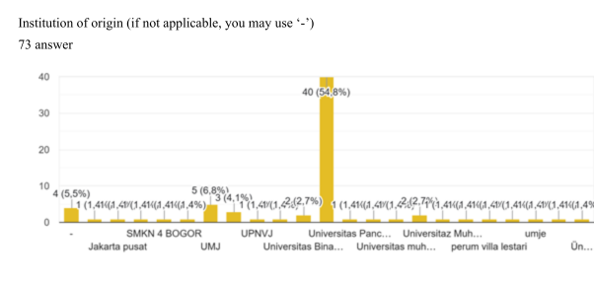
Figure 1. Participants’ Institutional Backgrounds in the Webinar & Workshop

In terms of academic programs, participants were dominated by Information Technology Engineering students, numbering 32 (62.0%), followed by Information Technology students at 5 (6.8%), and smaller numbers from other programs such as Law (International Relations), PPLG, and Computer Engineering. This composition indicates that most participants had an information technology background, yet the activity also attracted interest from those in other disciplines seeking to develop digital skills.
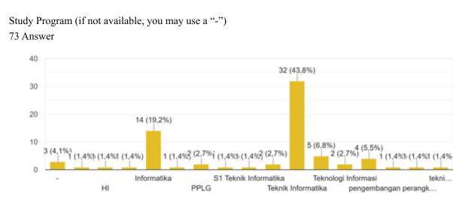
Figure 2. Study Programs of Webinar & Workshop Participants
To measure improvements in participants' understanding, a pretest was conducted before the activity and a posttest after the completion of all webinar and workshop sessions. The measurement results showed a significant enhancement in participants' knowledge regarding business website development.
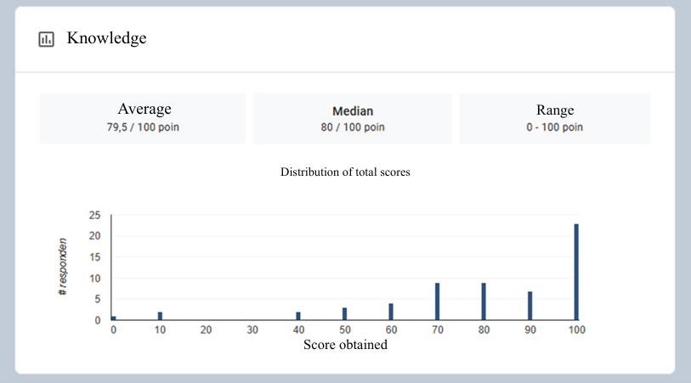
Figure 3. Participants’ Pre-Test Results
The pretest yielded an average score of 79.5 out of 100, with a median of 80. Scores ranged from 0 to 100, indicating substantial variation in initial abilities. The wide distribution of scores suggests that some participants had limited understanding of basic website development and responsive design concepts, while others possessed adequate prior knowledge.
Following the pretest, the webinar was implemented, focusing on conceptual materials about the role of business websites, web development fundamentals, and Bootstrap-based responsive design principles. In this session, participants engaged in online material presentations accompanied by interactive discussions. Participants' enthusiasm was evident in their active participation during Q&A sessions, reflecting their interest and need for foundational business website development knowledge.
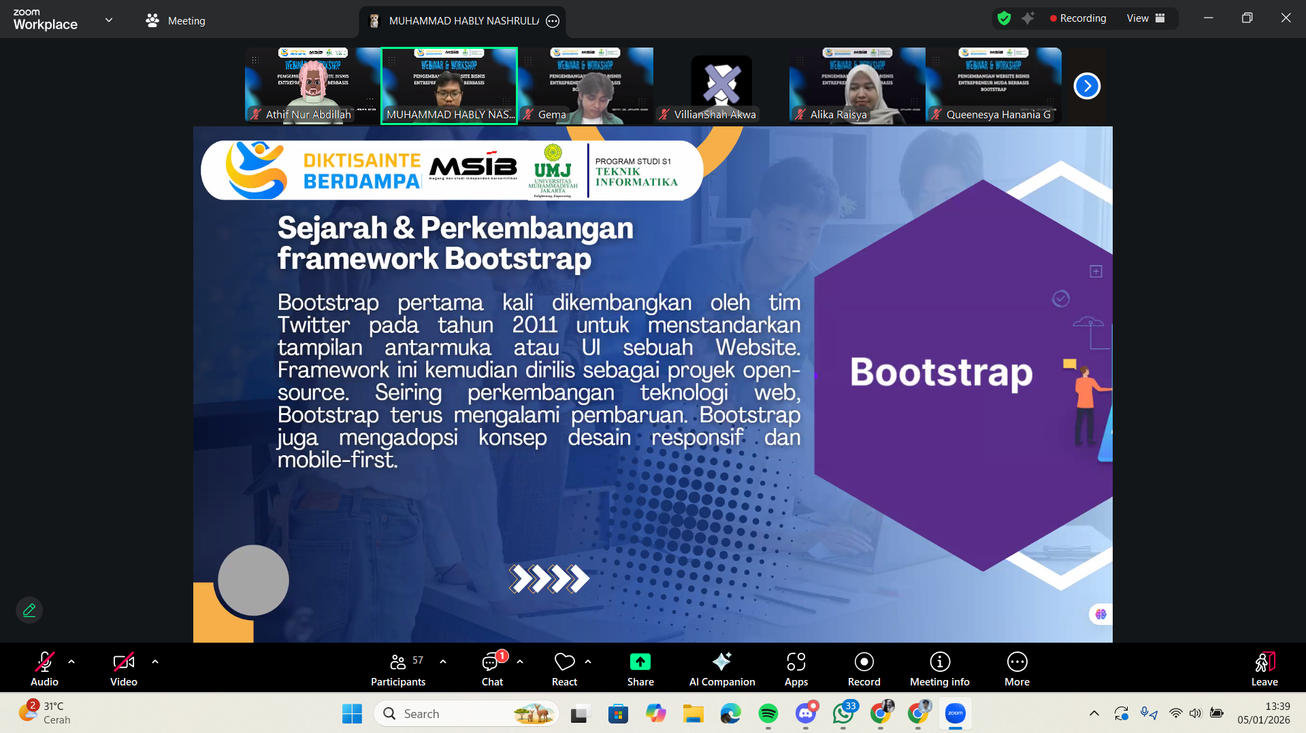
Figure 4. Webinar Activity Documentation
After gaining conceptual understanding through the webinar, the activity proceeded to workshop sessions emphasizing hands-on business website development. At this stage, participants were guided to construct page structures, apply responsive layouts, and implement Bootstrap components progressively. The workshop sessions were designed to be interactive, allowing participants to experiment, ask questions, and refine their website developments in real-time.

Figure 5. Workshop Activity Documentation
At the end of the activity, a posttest was administered, resulting in an improved average score of 92.32 and a median of 100. The score range narrowed to 60–100, indicating no participants with very low scores. The score distribution concentrated in the high range, with 31 participants achieving perfect scores. This outcome signifies that the majority of participants comprehensively mastered the material after completing the learning series.
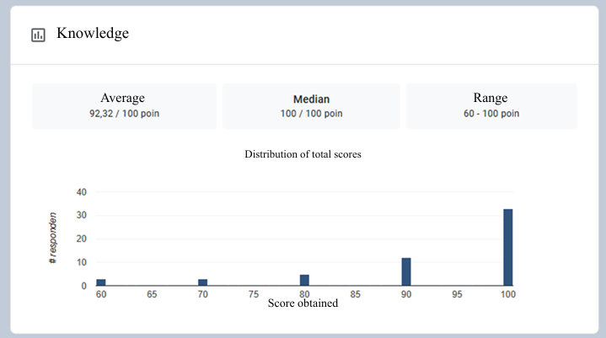
Figure 6. Participants’ Post-Test Results
A comparison of the two results reveals a clear enhancement in knowledge. The shift from a dispersed pretest distribution to a concentration in high scores on the posttest confirms that the method of delivering conceptual materials via webinar, followed by hands-on workshops, effectively reinforced participants' understanding. These results demonstrate that participants not only acquired theoretical knowledge but also internalized concepts and applied them independently. Thus, the pretest and posttest outcomes prove that the community service program successfully enhanced participants' knowledge and digital literacy in Bootstrap-based business website development.
As a form of program implementation evaluation, participants were also asked to provide feedback on the activity. The feedback indicated overwhelmingly positive responses to the webinar and workshop execution. These evaluation results serve as additional indicators that the activity was not only effective in improving knowledge but also successfully delivered with high quality.
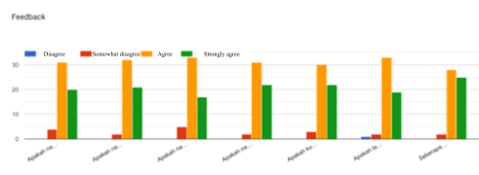
Figure 7. Participants’ Feedback Results
Based on the provided evaluation parameters, the suitability of resource persons with their field of expertise received positive responses. Webinar resource persons were rated as competent in delivering the material, while workshop resource persons were deemed capable of guiding participants according to practical website development needs. Regarding resource persons' ability to present materials, participants rated the explanations as clear, structured, and easy to understand, both in conceptual and hands-on sessions.
From the perspective of online service quality during the activity, audio and visual display aspects in the workshop were rated good and did not impede the learning process. Additionally, online administrative services, such as registration and activity access, were evaluated as user-friendly, supporting smooth participant engagement. Overall participant satisfaction was high, with the majority expressing contentment with the materials, delivery methods, and supporting facilities.
In general, feedback results showed that nearly all parameters received ratings from "agree" to "strongly agree." Only a few "disagree" ratings appeared on specific points, but they did not significantly impact the overall assessment. These findings affirm that the community service activity was well-executed and positively received by participants.

CONCLUSIONS
This community service program implemented through webinars and workshops on Bootstrap-based business website development successfully enhanced participants’ knowledge and digital skills. The diversity of participants’ institutional and academic backgrounds demonstrates that the program effectively reached a broad audience and attracted interest from individuals across different disciplines in developing digital competencies.
Evaluation results indicate a significant improvement in participants’ understanding, as reflected by the increase in average pretest scores from 79.5 to 92.32 in the posttest, along with a shift in score distribution toward the high range. In addition to conceptual knowledge gains, participants were able to produce responsive and functional business website prototypes, signifying effective transfer of practical web development skills.
The success of the program is further supported by participant feedback, which showed high satisfaction with material relevance, resource person competence, and online service quality. This confirms that the applied learning methods not only improved participants’ capabilities but also provided a structured and comfortable learning experience.
Therefore, the combination of webinars for theoretical reinforcement and workshops for hands-on practice proved effective in strengthening digital literacy and enabling participants to independently develop business websites. This program has strong potential to be replicated as a model for similar training initiatives in supporting sustainable community digital transformation.

ACKNOWLEDGEMENTS
The authors and team would like to thank Information Technology Study Program, University of Muhammadiyah Jakarta, Fakultas of Engineering, for their support in the implementation of this community engagement program. The authors also express their gratitude to all participants who actively joined the webinar and workshop entitled “Development of a Simple Business Website for Young Entrepreneurs Using Bootstrap”.

AUTHOR CONTRIBUTIONS
Activity Implementation: Gema Vizayaksa, Alika Raisya, Muhammad Habbly Nashrullah, Muhammad Arifin Ilham, Villian Shah Akwa. Material Delivery: Muhammad Habbly Nashrullah, Workshop Execution: Alika Raisya, Document Preparation: Gema Vizayaksa, Alika Raisya, Muhammad Habbly Nashrullah, Manuscript Writing & Revision: Hendra, Nurvelly Rosanti, Yana Adharani, Rully Mujiastuti.

REFERENCES

Adhaini zahra Nasution, Rian Farta Wijaya, & Batubara, S. (2025). Perancangan Website Pendukung Pembelajaran Kelas dengan Framework Bootstrap ( Studi Kasus : SMK Telkom 1 Medan). Jurnal Komputer Teknologi Informasi Sistem Informasi, 519-530. Diambil kembali dari https://doi.org/10.62712/juktisi.v4i2.466
Buchori, A., Rahmadhani, T., Rozzaqi, A., & Khoiri, N. (2025). Developing web-based learning media for enhancing digital literacy in computer networking. Indonesian Journal of Educational Development, 737–751. Diambil kembali dari https://doi.org/10.59672/ijed.v6i3.5361
Erwandi, Y., Siregar, R., Anggara, J., Fadilah, I., Ariyanto, R., & Rahmadan, B. (2025). Edukasi literasi digital melalui pelatihan web development dasar sebagai upaya peningkatan kualitas siswa SMK Negeri 6 Kota Bengkulu. Kohesi: Jurnal Multidisiplin Saintek. Diambil kembali dari https://doi.org/10.8734/Kohesi.v1i2.365
Harahap, A., Nasution, A., Gunawan, H., & Sari, R. (2023). Training Easy Ways to Learn to Build Web with Bootstrap. Indonesian Journal of Advanced Social Works (DARMA), 141–148. Diambil kembali dari https://doi.org/10.55927/darma.v2i3.5482
Ika Safitri Windiarti, Miftahurrizqi, & Haryanto, D. (2022). Peningkatan Literasi Digital Melalui Pelatihan Pengelolaan Website Di Pondok Pesantren Salafiyah Iqro Palangkaraya. Jurnal Pengabdian Untuk Mu NegeRI, 2550, 0198. Diambil kembali dari https://doi.org/10.37859/jpumri.v6i2.3947
Muhammad Risyad Fadilah, U. F. (2024). Pengembangan Website Responsif Menggunakan Framework Bootstrap. Karimah Tauhid, 1. Diambil kembali dari https://doi.org/10.30997/karimahtauhid.v3i11.15407
Sugiharto, S. (2024). Pelatihan Pemrograman Web Front-End dengan Bootstrap. SWARNA: Jurnal Pengabdian Kepada Masyarakat, 611–615. Diambil kembali dari https://doi.org/10.55681/swarna.v3i10.1385
Supiyandi, S., Lingga, C., Firtiani, A., Tanjung, A., & Malau, S. (2024). Training responsive web applications and web content in multimedia web programming. JURIBMAS: Jurnal Hasil Pengabdian Masyarakat, 159. Diambil kembali dari https://doi.org/10.62712/juribmas.v2i3.159
Veranita, M., Yusuf, R., Sahidin, Y., Susilowati, R., Fatihah, D. C., & & Warsiati, W. (2021). Empowering UMKM Dengan Pemanfaatan Digital Marketing Di Era New Normal (Literasi Media Digital Melalui Webinar): Literasi Media Digital melalui Webinar. Jurnal Pengabdian Kepada Masyarakat UBJ, 159-168. Diambil kembali dari https://doi.org/10.31599/jabdimas.v4i2.585
Wayahdi, M., Ginting, S., & Ruziq, F. (2023). Pelatihan Membangun Website Portofolio Menggunakan Bootstrap V5.3 Pada Siswa/i SMK Swasta Jambi Medan. PRAXIS: Jurnal Pengabdian Kepada Masyarakat, 86–94. Diambil kembali dari https://doi.org/10.47776/praxis.v2i1.715

